What is The Nature and Scope of Management?

Management is a critical factor that acts as a growth magnet for a business. A manager will bring together people, resources, and processes to meet organizational goals. It entails strategic application of best practices for:
- Coordination
- Direction
- Management of resources, and
- Planning
Good management means knowing the theory and principles of management. This lets managers inspire propel and streamline processes.
The right concepts of management enable companies to align with the evolving business environment and prepare to unlock future opportunities.
Today’s post explores the nature and scope of this interesting topic.
With this knowledge, you can sharpen your management skills to deliver exemplary business value. To be a high-impact manager, it is important to know about the nature and scope of management.
Do you want to find out how the concept of management can help businesses grow? Do you want to know what it takes to be a good manager? Well, worry no more, we have given you a detailed explanation of the concept as a guide.

What is Management?
Management is about:
- Planning what needs to be done and how it needs to be done
- Organizing team and things to do the work
- Making sure the work gets done right
Management changes how we work. It involves:
- Deciding what work to do and who should do it
- Choosing how to use resources like money, time, and tools
- Making sure workers know how to do their jobs well
- Checking that the work is good enough for customers
Outcome-oriented management tries to get the best results by guiding people and using resources wisely.

What is The Nature and Scope of Management?
Let us consider each of these terms separately and analyse how they work in the province of management.
Nature Of Management
In this systematic process, management assists in defining a set of people who perform specific activities, thus enhancing the performance of an organization. The following are the features that explain the nature of management in businesses.

[1] Coordination
Management runs an organisation’s operations by assembling various groups and divisions. If there is no coordination, there will be confusion and disorder. Thus, by aligning the people, there is communication and reduced work overlap.

[2] Social Process
Management is all about organizing teams and then managing them. It calls for varying degrees of empathy and flexibility. Apart from managing social and emotional needs, it involves creating, encouraging and maintaining employees.

[3] Dynamic Function
Management should be dynamic in its nature because business organizations are usually affected by:
- Political
- Economic
- Technological factors
When people are ready to get flexible and have some skills to control even stressful situations, it is easier to survive and succeed in any given circumstance. But there needs to be proper training and support also throughout the process.

[4] Intangible
There is no tangible proof of how the management works. Its success can be judged by the results of its actions. For instance, lower turnover rates propose that workers are engaged and cheerful. This also shows that managers have effectively worked to hold workers back from leaving.

[5] Creativity
Management has various elements that come together as a process. All the elements have their own significance. For instance, teamwork encourages creativity and innovation. When the standalone efforts come together, they produce added value, and a new creation comes into being.

[6] Universal Impact
In every company, management is practiced. Whenever a group of people works, there is always management. Management principles apply to all businesses regardless of geographical location or size. This universal principle also implies that management skills can be learned over time, and are also transferrable.

[7] Purposeful
The main intention of management is always relative to achieving the goals, mission and vision of an organization. The success of management can be seen in terms of the degree of accomplishment of the set goals by an organization.
There is always the hidden agenda of increasing productivity. The objectives should be specific, measurable and achievable within a given period.
Scope Of Management
The scope of management is characterized by specific duties, ideas, principles, and theories associated with managerial assignments. Let us explore the different parts of this.

[1] Personnel Management
Personnel management, as the name implies, focuses on managing people in a workplace. It includes:
- Recruitment
- Termination of individuals
- Taking care of employees’ welfare and benefits
There is no doubt that this aspect of management is important because people are organized into teams, and teams help to achieve the goals of the organization. Every contributor plays a role. If the requirements and issues of employees are not met, problems could arise for the organization.

[2] Office Management
This means managing all the given office's activities to help achieve a particular organization's aims and objectives. For instance, the efficiency of management greatly affects the performance of a business. The more coordinated the departments and tasks are, the better an organization runs.

[3] Financial Management
Financial management is a priority in every enterprise because finances can become very complicated if handled incorrectly. Efficient management of funds ensures that the stakeholders receive fair returns on their investments and that the amount of money required in the future can be estimated properly. This includes analyzing financial reports and engaging with stakeholders.

[4] Production Management
This type of management is about making valuable products or services. When you change inputs into outputs and look after the planning and controlling, it is referred to as production management.
Without production, there is no end product or service, and without it, organizations cannot attract customers' demand or make a profit. The final product must meet the needs of the customers. This process includes:
- Making sure the quality is good
- Research and development
- Designing the production layout
- Finding easier ways to do things

[5] Marketing Management
The scope of management in marketing involves planning and controlling the actions of the marketing team. It is essential to identify what customers need so that effective business solutions can be offered.
When a manager knows the benefits of the company's products and services, they get better results. Marketing management helps make sure resources are used wisely to achieve the best results possible.

The 5 Skills to Learn for Effective Management
Management means learning several skills that will help you in working with people and fulfilling a certain vision of the organization. Here are a few management skills that may be given more attention than others:

[1] Decision-Making
Making good decisions requires:
- Collecting necessary information
- Looking at possible choices
- Thinking about the consequences of those choices
- Making decisions on time and with the right facts
It is necessary to strike a good balance between using one’s gut feeling and relying on data.

[2] Leadership
Management skills are vital in the process of directing people towards the achievement of organizational objectives. These are aspects such as communication, understanding, motivation, and leadership.
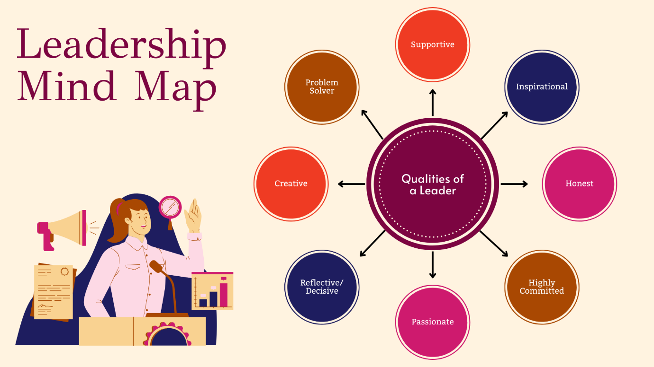

[3] Project Management
It is important to know the basics of project management, including:
- Planning
- Scheduling
- Budgeting
- Risk management
This will help you manage projects from start to finish successfully.

[4] Strategic Thinking
Managers must strategize in advance so that the activities of the firm align with its overarching objectives. This entails assessing trends within their industry and making proactive decisions for the organization’s development and sustainability.

[5] Communication
Communication is a vital tool that enables us to give directions and feedback in the most appropriate manner. This entails the ability to speak, write, and listen effectively.

Important Tips for Efficient Management
Do you want to be a leader, not just a boss? Good leaders take care of their team and help the company do well. It is not easy, but it's worth it.
Leaders do many different jobs. This helps get things done. It is important to know the difference between leading and managing.
Anyone can learn to be a leader. Even people at lower levels in a company can become good team members by learning leadership skills.
Here are some tips to be a better leader:

[1] Time Management
Setting priorities and deadlines is key to helping a team work more efficiently and achieve the organization’s goals. This is a basic part of strategic management techniques.
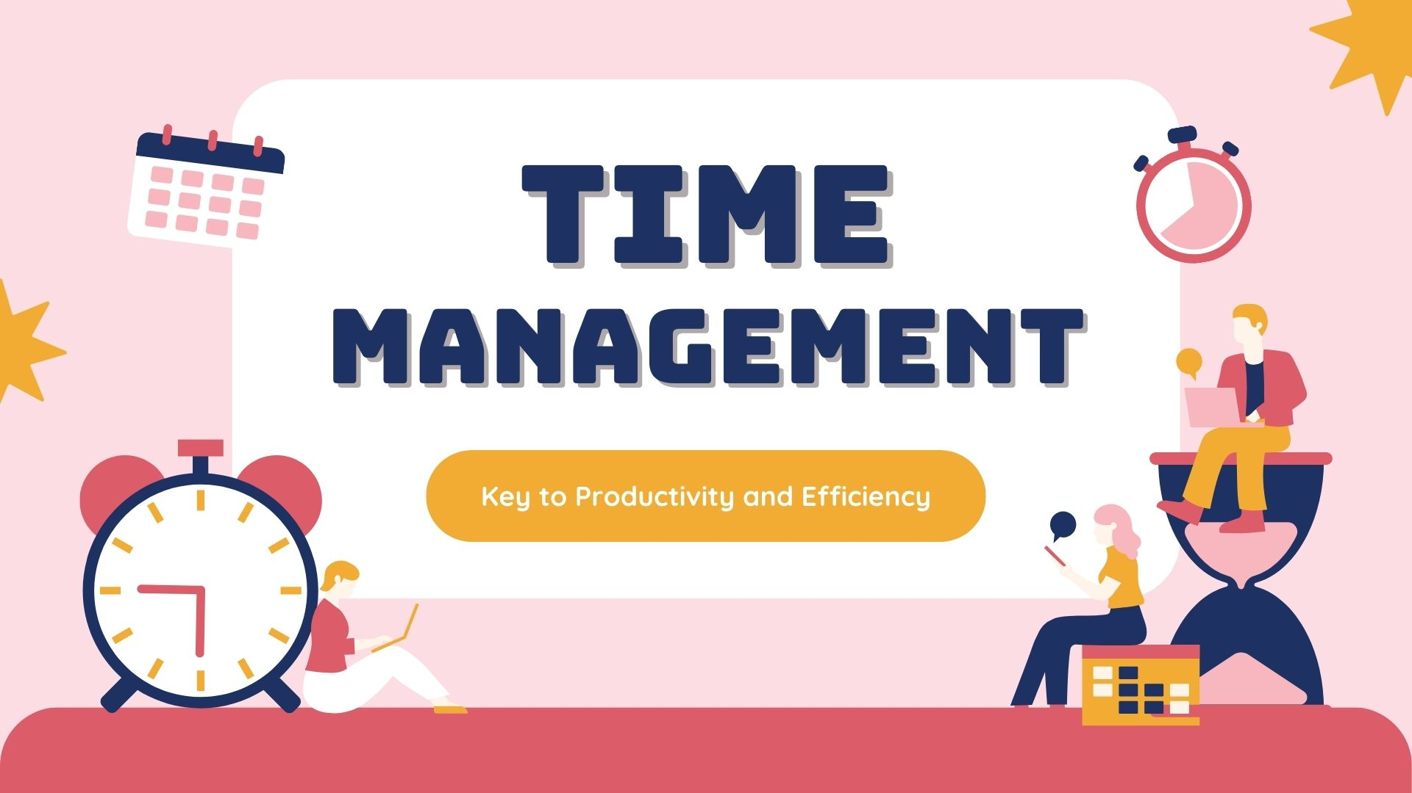

[2] Goal Setting
Set easy-to-understand goals for your team and company. Decide which tasks are most important and need to be done first. Make sure your product and service are delivered with top quality and finished on time.

[3] Create a Positive Working Culture
It is crucial to promote a good workplace as it affects the employees’ morale and productivity. You have to create an environment for the team where every member feels respected. A healthy approach to work interference involves making sure employees know their worth through recognition and positive feedback.

[4] Distribution of Tasks and Duties
This step is crucial for effective leadership. Tasks must be assigned according to the team member's strengths and weaknesses. This will ease the work burden for the team leader and help personal improvement.

Which are the Best management courses and schools in India?
Here's a table summarizing the management courses, their eligibility criteria, job opportunities, and average salaries:
Course Name | Duration | Eligibility Criteria | Job Opportunities | Average Salary | Top Universities
Master of Financial Management (MFM) | 2 years | Bachelor's degree with at least 50% (45% for reserved category). Preferred subjects: Trade or finance. 2 years of work experience in finance is often required. | Financial Analyst, Investment Manager, Stock Broker | Rs 7 LPA to Rs 35 LPA | Jamnalal Bajaj Institute of Management Studies (JBIMS)
Master in Management Studies (MMS) | 2 years | Bachelor's degree with at least 50% (45% for reserved category). Final-year students can apply but must provide original documents during admission. | Investment Banker, Project Manager, Marketing Manager | Rs 3 LPA to Rs 10 LPA | K. J. Somaiya Institute of Management Studies and Research, Mumbai
Master of Business Administration (Retail Management) | 2 years | Bachelor's degree with at least 45%. Open to all academic backgrounds. Entrance exams: CAT, XAT, or MAT. | Retail Manager, Supply Chain Manager, Marketing Manager | Rs 3 LPA to Rs 10 LPA | Birla Institute of Management Technology, Greater Noida
Master in Marketing Management (MMM) | 2 years | Bachelor's degree with at least 45%. Open to all academic backgrounds. | Marketing Manager, Brand Manager, Account Manager | Rs 40,000 to Rs 65,000 per month | Sydenham Institute of Management Studies, Research and Entrepreneurship Education, Mumbai
Master in Risk Management | 1 year | No prerequisites needed. | Financial Risk Manager, Operational Risk Manager | Rs 11 LPA | Indian Institute of Technology, Kharagpur
Post Graduate Diploma in Management (PGDM) | 2 years | Bachelor's degree with at least 50%. | Marketing Manager, Sales Manager, Supply Chain Manager | Rs 4 LPA to Rs 7 LPA | Indian Institute of Management, Bangalore
PGDM in International Business | 2 years | Bachelor's degree with at least 50%. Candidates with less than 50% must take a Standard Entry Test. | Business Manager, Relationship Manager | Rs 20,000 to Rs 3 LPA | Institute of Management Technology (IMT), Ghaziabad
Project Management Professional Certification | 2 years | Four-year degree with 36 months of project management experience. | Project Manager, Project Designer | Rs 3 LPA to Rs 7 LPA | Indian Institute of Management, Ahmedabad
Diploma in Event Management | 1 year | 10+2 in any stream from a recognized board. | Event Planner, Event Coordinator | Rs 3 LPA to Rs 4 LPA | National Institute of Event Management (NIEM), Mumbai
 |  |  |  | Rs 3 LPA to Rs 8 LPA | Institute of Hotel Management (IHM), Delhi
  Diploma in Hotel Management
  3 years
  10+2 with a minimum of 40% marks and English as a compulsory subject.
  Hotel Manager, Catering Manager, Cruise Ship Manager

The Best management courses and schools in Abroad

Here are the top 10 best management courses for studying abroad along with the universities that offer these courses.

Management Courses | Universities
MSc in Business Analytics | University of California - San Diego, University of Texas at Dallas, University of Texas at Austin
Masters in International Management | University of Adelaide, IU International, Northeastern University, University of Applied Sciences, University of Texas at Dallas
MSc Strategic Management | University College Dublin, CBS International Business School, HEC Paris, University of York
Master in Engineering Management | Cornell University, RMIT University, RWTH Aachen, University College London, Massachusetts Institute of Technology
MSc Management and Strategy | LSE, HEC Paris, University of Birmingham
Masters in Management | London Business School, INSEAD, Bocconi University, IE Business School, ESCP Europe, University of St. Gallen
Master of Financial Management | Texas A&M University, Australian National University, Boston University, Lincoln University, Bond University
MSc in Strategy & Management of International Business | Aston Business School, University of York, Lancaster University
MSc in Business Management | University of Hull, University of West England, University of British Columbia, New European College
Master in Risk Management | St John’s University, New York Institute of Technology, Queens College

These top management courses are accessible to international students at well-known universities worldwide. The courses last 1 to two years, and the fees and admission requirements differ by university.

How an upGrad can help to Study Abroad Online?
upGrad helps students’ study abroad online by:
- Offering a unique study abroad model where students can enroll in courses at top global universities.
- Allowing students to start their studies from home, earning credits online.
- Providing guidance, mentorship, and support from skilled instructors throughout the learning journey.
- Enabling students to save on tuition fees and living costs by studying online from home.
- Offering personalized mentorship to support students' academic goals.
This approach allows students to pursue international education despite travel restrictions, making global learning more accessible and affordable.

Conclusion
Management plays a crucial part in the progress of any company, and figuring out its nature, scope, and required skills is fundamental for anybody trying to lead. So, by pursuing the right education and focusing on key management principles, you can prepare for a rewarding profession.
FAQs
[1] What roles does management play?
Management has five primary roles. Here are the following:
- Staffing
- Organizing
- Planning
- Leading
- Planning
[2] Why scope of management is necessary?
The scope of management is very relevant because it marks the limits and duties of people in a workplace. It brings out clarity and effectiveness in carrying out the activities. It helps in setting goals and making decisions.
[3] How long is a typical management course?
Most management courses last between 1 to 2 years.
[4] Can I study management courses online?
Yes, many online platformers like upGrad offer online management courses. This allows flexibility in learning.
[5] What are the advantages of good management?
Efficient management has many advantages, including:
- Improved output
- Better involvement of employees
- Assisting in improving decision-making skills
- Greater adaptability
[6] What are the key skills required for effective management?
- Leadership
- Communication
- Strategic thinking
- Decision-making
- Project management
These are essential skills for effective management.
[7] Why is communication so essential in management?
Effective communication is important for ensuring alignment. This helps prevent confusion and helps to work together within groups.



